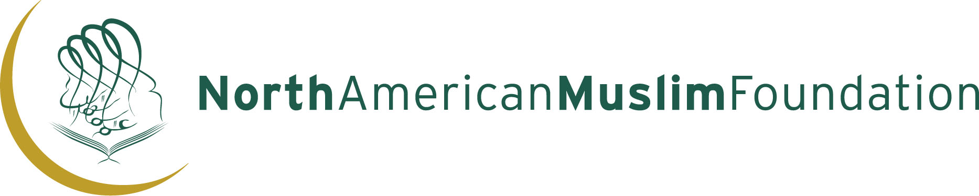

APPLICATION FOR BAZAAR SPACE
NAMF Family Fair 2018
Monday, February 19, 2018
Venue: NAMF Islamic Center
4140 Finch Avenue East, Scarborough Ontario M1S 3T9
Between Kennedy Road and Midland

Please print clearly

NAME OF BUSINESS: _________________________________________________________________
NAME OF OWNER: ___________________________________________________________________
ADDRESS: __________________________________________________________________________
TELEPHONE: Home________________ Bus__________________ Fax ________________

Please identify items to be sold/ exhibited:
__________________________________________________________________________________________________________________________________________________________________________

RATES: Per Table $150.00 (9:00 am to 9:00 pm)

Number of tables required:

_______ $150.00 x _______ = ________

Electrical Outlets: YES____ NO____ (add $50.00 per outlet) $50.00 x _______ = ________

TOTAL: $________

VISA # / MC #_________________________________________ Exp Date: _________________________

Maximum of 2 tables allowed per vendor

The number of tables available is limited and allocation will be on first come first serve basis
North American Muslim Foundation RESERVES THE RIGHT OF ADMISSION

LAST DATE TO SUBMIT NAMF Family Fair APPLICATION
Monday, February 16th, 2018

To guarantee a space the office must receive: a completed application form; signed terms and conditions letter and fee payable (VISA/MC) payable to NAMF by the last due date.

____________________________ __________________________
Signature Date

4140 Finch Avenue East, Scarborough Ontario M1S 3T9
Tel: 416-299-1969 Fax: 416-299-4890 Email: info@bellnet.ca Website: www.namf.ca

